**Name: Adithya M SRN:PES1UG20CS621 SEC: K**

#include <stdio.h>

#include <stdlib.h>

#define MAX 10

typedef struct Queue

{

int a[MAX];

int front;

int rear;

} queue;

void init(queue *q)

{

q->front = 0;

q->rear = -1;

}

int isEmpty(queue *q)

{

return (q->rear == -1);

}

int isFull(queue *q)

{

return (q->rear == MAX - 1);

}

void enqueue(queue *q, int ele)

{

if (isFull(q))

printf("Queue is Full\n");

else

{

q->rear++;

q->a[q->rear] = ele;

}

}

void dequeue(queue *q)

{

if (isEmpty(q))

printf("Queue is Empty\n");

else

{

for (int i = q->front; i < q->rear; ++i)

{

q->a[i] = q->a[i + 1];

}

q->rear--;

}

}

void display(queue *q)

{

for (int i = q->front; i <= q->rear; ++i)

printf("%d\t", q->a[i]);

printf("\n");

}

int main()

{

queue q;

int choice,ele;

init(&q);

do

{

printf("1:Display 2:Enqueue 3:Dequeue\n");

scanf("%d", &choice);

switch (choice)

{

case 1:

display(&q);

break;

case 2:

printf("Enter a Element\n");

scanf("%d", &ele);

enqueue(&q, ele);

break;

case 3:

dequeue(&q);

break;

}

} while (choice < 4);

return 0;

}

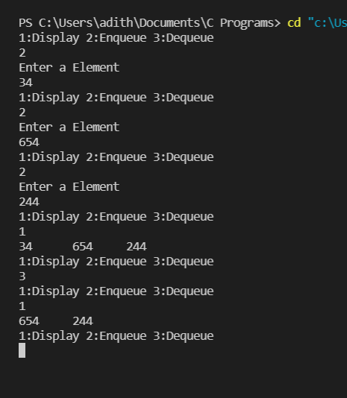

Program 2:

#include <stdio.h>

#include <string.h>

#define MAX 5

typedef struct node

{

char name[50];

int case_no;

int date;

int time;

} node;

typedef struct queue

{

node c[MAX];

int front, rear;

} queue;

void init(queue *lq)

{

lq->front = 0;

lq->rear = -1;

return;

}

int isfull(queue *lq)

{

if (lq->rear == MAX - 1)

{

return 1;

}

return 0;

}

void add(queue *lq, char *na, int casen, int dat, int t)

{

strcpy(lq->c[++lq->rear].name, na);

lq->c[lq->rear].case_no = casen;

lq->c[lq->rear].date = dat;

lq->c[lq->rear].time = t;

}

void remove(queue *lq)

{

if (lq->front > lq->rear)

{

printf("Empty Appointments\n");

return;

}

printf("Cancelled Case %d\n", lq->c[lq->front++].case_no);

return;

}

void display(queue *lq)

{

if (lq->front == -1)

{

printf("Empty Appointments\n");

return;

}

if (lq->front > lq->rear)

{

printf("Empty Appointments\n");

return;

}

for (int i = lq->front; i <= lq->rear; i++)

{

printf("Name : %s\n", lq->c[i].name);

printf("Case : %d\n", lq->c[i].case_no);

printf("Date and Time : %d %d", lq->c[i].date, lq->c[i].time);

printf("\n");

printf("\n");

}

return;

}

int main()

{

queue q;

int n, case_no, date, time;

char name[50];

init(&q);

do

{

printf("1.Book 2.Display 3.Cancel Appointment");

scanf("%d", &n);

switch (n)

{

printf("\n");

case 1:

if (isfull(&q))

{

printf("No slot available\n");

break;

};

printf("Enter name: ");

scanf("%s", name);

printf("Enter case number: ");

scanf("%d", &case_no);

printf("Enter date and time: ");

scanf("%d %d", &date, &time);

add(&q, name, case_no, date, time);

break;

case 2:

display(&q);

break;

case 3:

remove(&q);

break;

}

printf("\n");

} while (n< 4);

}

